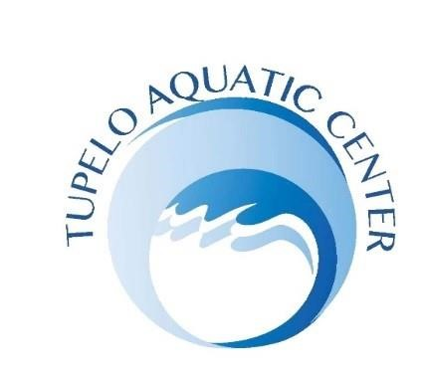
Lifeguard Class
The American Red Cross Lifeguard training course prepares individuals to assume the duties and responsibilities of lifeguards at swimming pools. This course provides the knowledge and skills designed to save the life of another person in the event of an emergency.
Eligibility: Must be at least 15 years of age by the end of the class and pass the American Red Cross pre-course test* consisting of the Swim-Tread-Swim. Swim 150 yards using front crawl/freestyle, breaststroke, or a combination of both while demonstrating breath control and rhythmic breathing, tread water for two (2) minutes, only using legs, and swim 50 yards using front crawl, breaststroke, or combination of both. *Complete a timed event within 1 minute and 40 seconds. Starting in the water, swim 20 yards, surface dive (feet or head first), return to surface and swim 20 yards on the back to return to the starting point with both hands holding the object and keeping the face at or near the surface so they are able to get a breath. Exit water without using a ladder or steps. Swim goggles are not allowed during the timed event.
American Red Cross First Aid and CPR for the Professional Rescuer is included in this course. Certificates issued only upon successful completion of required written test and physical skills. **In the event a participant does not pass the pre-course test, half of the registration fee will be refunded to the participant. OTHERWISE NO REFUNDS. Certification is valid for two (2) years. CIRCLE CLASS IN WHICH YOU WISH TO REGISTER.
Dates: Class # 1: March 13-14, 2026 |  | Registration and fee due by March 5.
Class #2: April 6, 2026 |  | Registration and fee due by March 26.
Class #3: May 8-9, 2026 |  | Registration and fee due by April 30.
Class #4: May 16-17, 2026 |  | Registration and fee due by May 7.
Class #5: May 23-24, 2026 Registration and fee due by May 14.
Class #6: December 18-19, 2026 Registration and fee due by December 10.

**Participants must attend all class days in order to complete the course. Anyone who is recertifying must attend designated class date.

Cost: The cost of the Lifeguard course is $250.00, cash or check (check payable to Tupelo Sports Council, TAG) or you can scan QR code at the bottom and pay by VENMO. Please put the participants name in the memo line. If you would like to pay by credit card please contact us and we can send you Square invoice. These classes will be taught as a Blended Learning Course (On-Line Course with On-line testing). Participant will do a skill(s) check at the facility with an instructor. You will be able to print your books on line. The cost covers all books and materials needed for the course, certification, and administrative costs. For recertification, the cost is $190.00. Make checks payable to the Tupelo Aquatic Group. If you are mailing the form, it must be reached by the deadline of registration date set above.

Mail or Deliver Form and fee to:
Tupelo Aquatic Center Name__________________________________________
P.O. Box 3608 (mailing)
692 N. Veterans Blvd. (physical address) Address________________________________________
Tupelo, MS 38803
Phone: (662) 840-3768 E-Mail (Print the email that you will receive the information by pertaining to the class)
Email: Amy.Kennedy@tupeloms.gov
_________________________________________


Phone #: ________________________ Date: ______________________

Signature of participant (18 and older) Signature of guardian of participant if 17 years and younger

